[**ИДЕЈЕ**](http://www.pinterest.com/morganfrost20/bow-and-arrow-catapult-etc/) **КАКО ДА САМИ НАПРАВИТЕ КАТАПУЛТ**

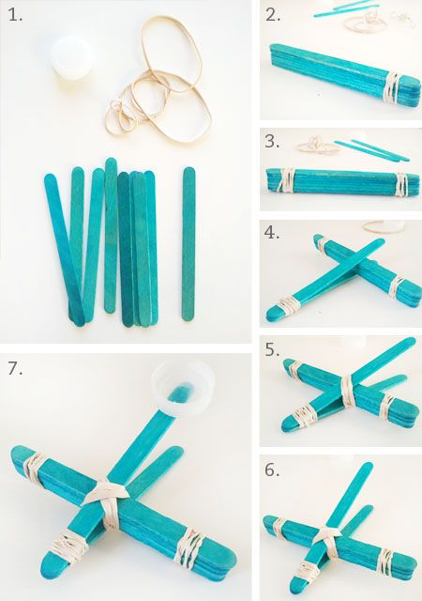 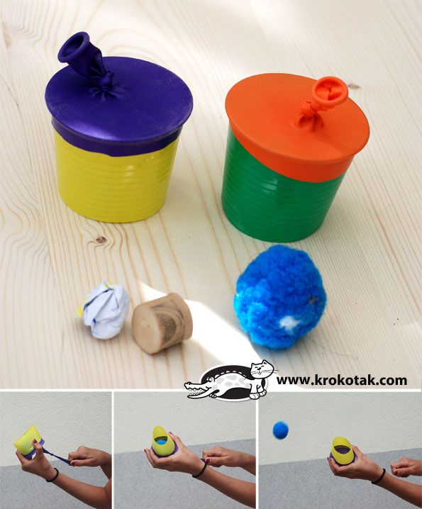

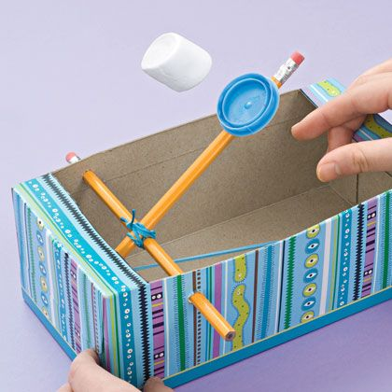 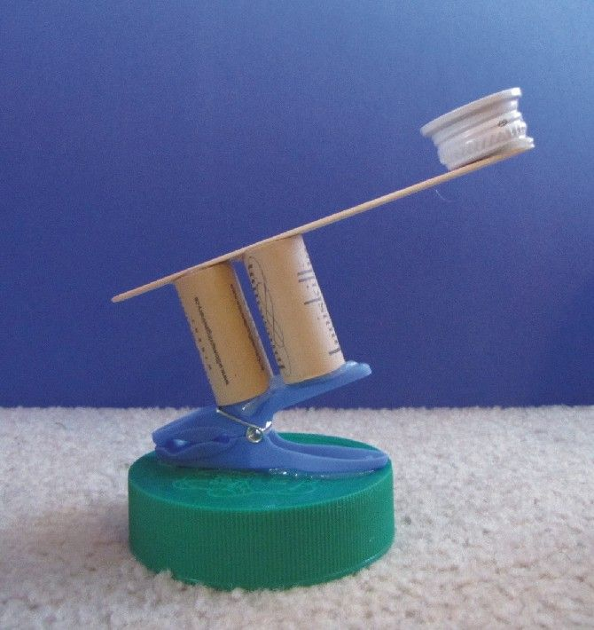

|  |  |
| --- | --- |
| C:\Users\Marina\Desktop\e35a9323f4f7bd1a15d1ba739f97f59d.jpg  C:\Users\Marina\Desktop\ae8e7fe2d6698fe693c417b42885bb95.jpg | C:\Users\Marina\Desktop\541f86328418d9bc8aa9c89e79e2589c.jpg |

|  |  |  |
| --- | --- | --- |
| C:\Users\Marina\Desktop\candy-corn-catapults-10.jpg | C:\Users\Marina\Desktop\331.jpg | C:\Users\Marina\Desktop\231.jpg |

Ево и странице где ћете наћи још идеја: <http://www.pinterest.com/morganfrost20/bow-and-arrow-catapult-etc/>